1. **URI - http://localhost:5000/**

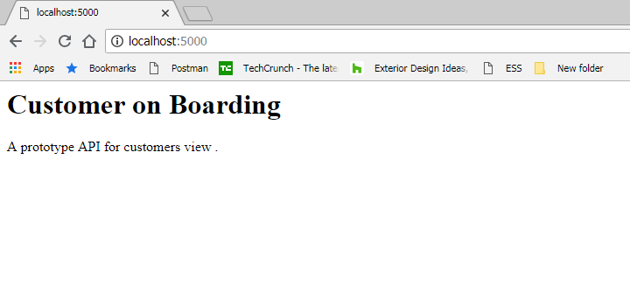

Service Method in Demo_app.py

*@app.route*(*'/'*, methods=[*'GET'*])

def **home**():

return *'''<h1>Customer on Boarding </h1>*

*<p>A prototype API for customers view .</p>*

*'''*

Script Response

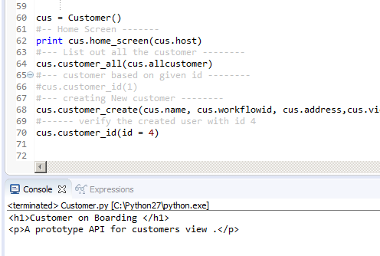

1. **URI to view list of all the users (which are already created )**

http://localhost:5000/api/v1/resources/customers/all

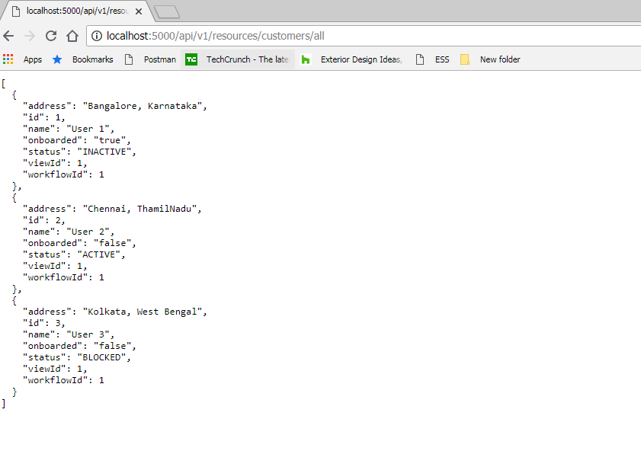

Service Method to list out all the user in Demo_app.py

*@app.route*(*'/api/v1/resources/customers/all'*, methods=[*'GET'*])

def **api_all**():

#status_code = 200

return jsonify(customers)

*'''({*

*'Json' : customers,*

*'Status' : 'OK',*

*'code': 200*

*})*

*'''*

Script will list out all the user existed

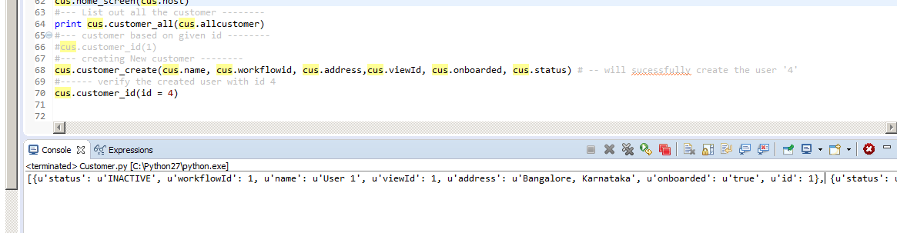

1. If not found (request not found) : -- displays Error 404

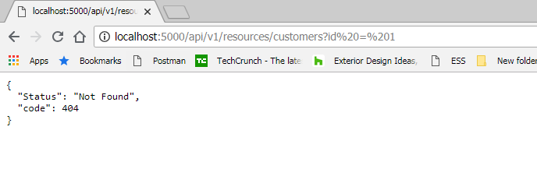

1. If Requested id found

URI for the requested id

http://localhost:5000/api/v1/resources/customers?id=1

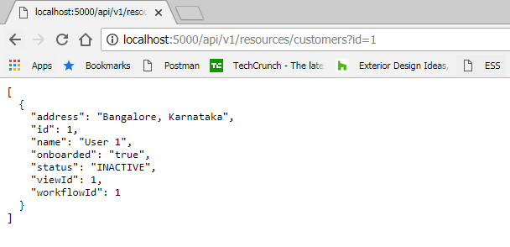

Services for the retrieving id

*@app.route*(*'/api/v1/resources/customers'*, methods=[*'GET'*])

def **api_id**():

# Check if an ID was provided as part of the URL.

# If ID is provided, assign it to a variable.

# If no ID is provided, display an error in the browser.

if *'id'* in request.args:

id = int(request.args[*'id'*])

else:

return jsonify({

*'Status'* : *'Not Found'*,

*'code'* : 404})

# Create an empty list for our results

results = []

# Loop through the data and match results that fit the requested ID.

# IDs are unique, but other fields might return many results

for custid in customers:

if custid[*'id'*] == id:

results.append(custid)

# Use the jsonify function from Flask to convert our list of

# Python dictionaries to the JSON format.

return jsonify(results)

Script Displayed output

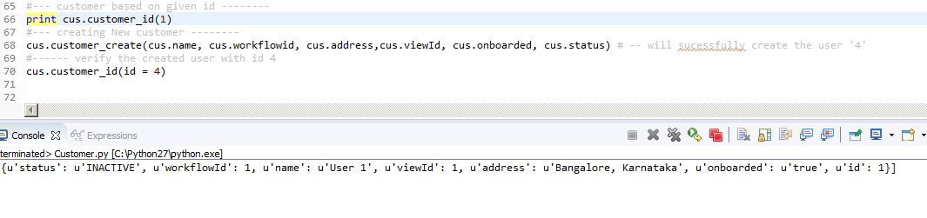

1. Creating the New Customer

Uri for creating the user

Script form the service side

*@app.route*(*'/api/v1/resources/customers/'*,methods = [*'POST'*, *'GET'*])

def **api_create**():

#return '''<h1>Creating user screen </h1>'''

if request.method == *'POST'*:

#r = request.args.get('name', '')

#print r

result = request.form[*'id'*]

result = {

*'id'*:int(request.form[*'id'*]),

*'name'*: request.form[*'name'*],

*'address'*: request.form[*'address'*],

*'status'*:request.form[*'status'*],

*'viewId'*: int(request.form[*'viewId'*]),

*'workflowId'*: int(request.form[*'workflowId'*]),

*'onboarded'*: request.form[*'onboarded'*]

}

print result

id =request.form[*'id'*]

jsonify(customers.append(result))

#print request.form['id']

return(id)

#return render_template("result.html",result = result)

Before Creating the user

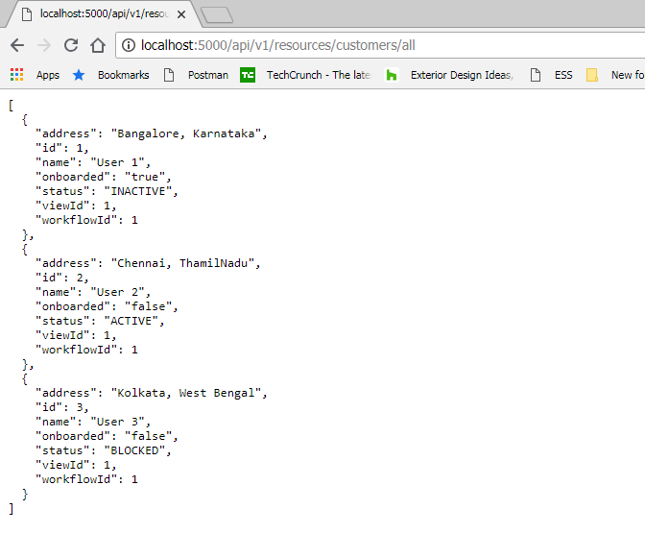

After Creating the user

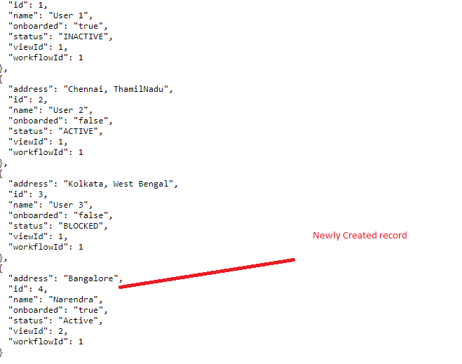

Scripts to create the customer (new), displayed the result with created id and status code

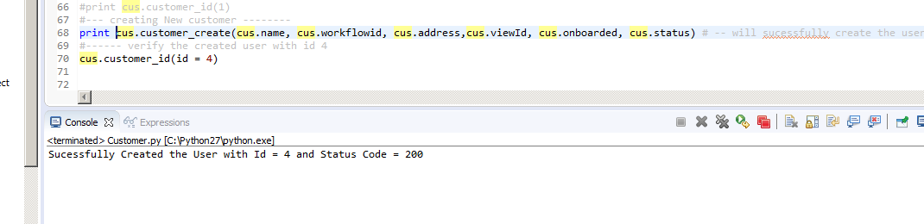

1. Verifying the created user

Uri to view the created record

http://localhost:5000/api/v1/resources/customers?id=4

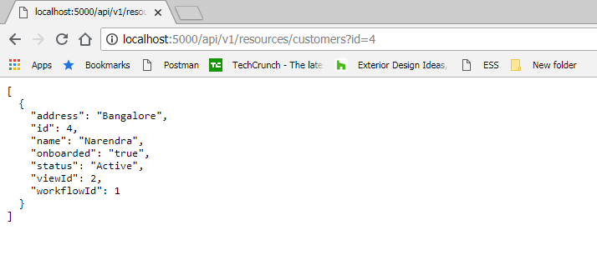

After Script execution

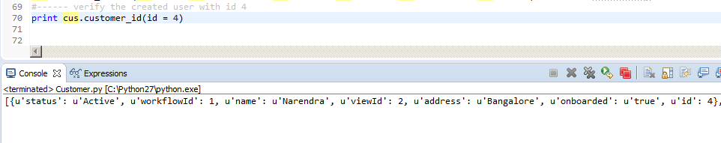

Sample

